**CREDIT EDA CASE STUDY**

Team Members :

* Nagarjuna Chereddy
* Jeeva Thangaraj

**Case Study -background**

• The finance company specializes in lending various types of loans to urban customers.

• The company receives loan applications and it make decisions for loan approval based on applicant’s profile.

• Two types of risks associated with the company’s decision:

a) the applicant likely to repay the loan, but not approving the loan result in loss of business to the company.

b) the applicant not likely to repay the loan, he/she likely to default, then approving that loan leads to loss to the company.

To Find out: Identify the dimensions and measures in the dataset which help in indicating the defaulters and use in making decision whether to approve the loan or reject the loan.

**From the bar graph applicants are applying mostly for cash loan.**

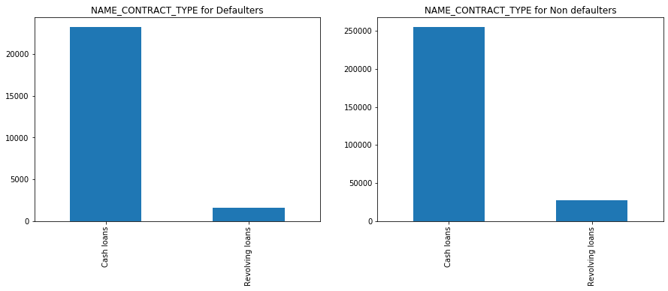

From above plot, we can say most of the applicants are applying for Cash loans and applicants applying for Revolving loans is almost negligible when compared with number of applicants with Cash loans.

**Most of the applicants are eligible for Credit amount of the loan >= 500000**

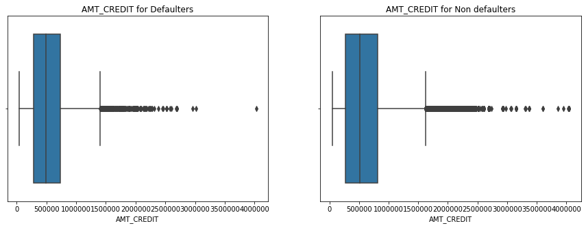

**Applicant Loan Status :**

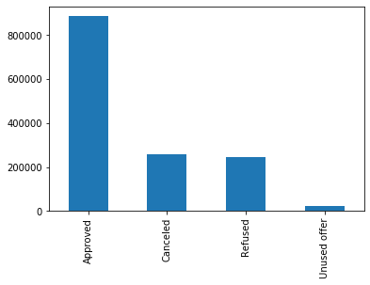

* Approved
* Cancelled
* Refused
* Unused offer

Almost 900000 customer loans are approved and very less customer loans are refused

**Total number of loans per “loan Purpose”**

* Cash loan
* Consumer loan
* Revolving loan

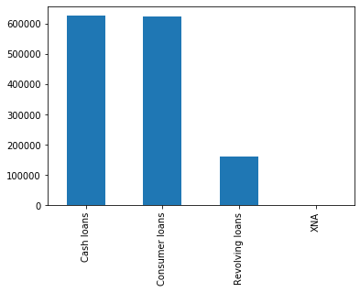

There are equal number of applicants for Cash loans and Consumer loans. We can see that the Revolving loans are small amount compared to Cash loans.

**Total number of Male and Female defaulters**

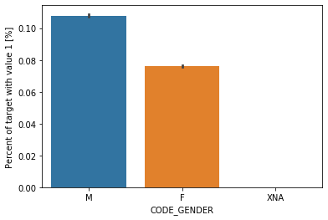

Males are more likely to be defaulted when compared to Females.

**Loan Contract status vs Defaulter**

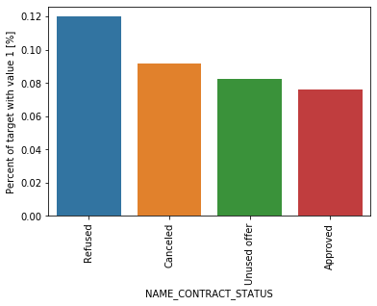

From above plot, we can say that most of the Refused applicants are likely to be defaulted.

Applicants with more children or more Family members are most certain groups to become defaulters.

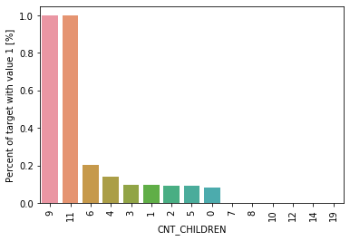

**Correlation:**

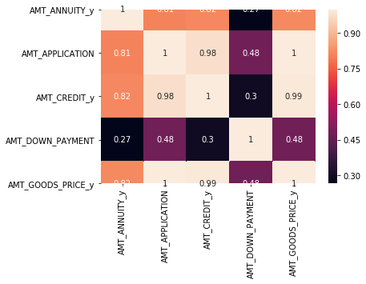

AMT_APPLICATION & AMT_GOODS_PRICE_y are highly correlated with each other and their correlation value is 1 which indicates that they are strong positive correlation. Aprt form this (AMT_CREDIT_y, AMT_APPLICATION), (AMT_CREDIT_y,AMT_GOODS_PRICE_y) are also have strong positive correlation as their correlation values are almost equal to 1

**Observations:**

* Males are more likely to be defaulted when compared to Females.
* 900000 customer loans are approved and very less customer loans are refused and there are negligible applicants who have Unused offer.
* Number of Female applicants are almost twice than that of male applicants.
* Applicants are applying for Cash loans and applicants applying for Revolving loans is almost negligible when compared with number of applicants with Cash loans.
* The medians are almost equal and there is higher interquartile portion above the median which means majority of the applicants are eligible for Credit amount of the loan >= 500000.
* For most of the applicants the Loan annuity is in between 10000 to 40000.
* Mean and Median salaries on Non defaulters who applied for Cash loans and Revolving loans are higher than the Defaulters.
* There is no Businessman and Student category in Defaulters plot which means they have repaid all their loans.
* Female applicants repaying the loans is more than not repaying the loans. In Males case, they are more like of getting defaulted as the likelihood of not repaying the loans in greater than repaying the loans.
* The applicants who earn by working are more likely to get defaulted. One more interesting point is there are no defaulters from Businessman and Student.
* The applicants with Secondary/Secondary special are more likely to get defaulted. There are significant number of applicants from Higher education as well.
* The applicants whose occupation type is Laborers are more likely to get defaulted as they get very less salaries.
* The are equal number of applicants for Cash loans and Consumer loans. We can see that the Revolving loans are small amount compared to Cash loans.
* We can say that there are around 10 lakh old customers in the applicants.
* Applicants with more children or more Family members are most certain groups to become defaulters.
* Percentage of applicant whose application is refused is more likely to be defaulted because he is not up to expectations in repaying the loans.

**Thank You**